**Name: Soham Bhoir**

**Roll No: 16010420117**

**Experiment: 8**

Install netbeans

Create new project

Select java with Ant

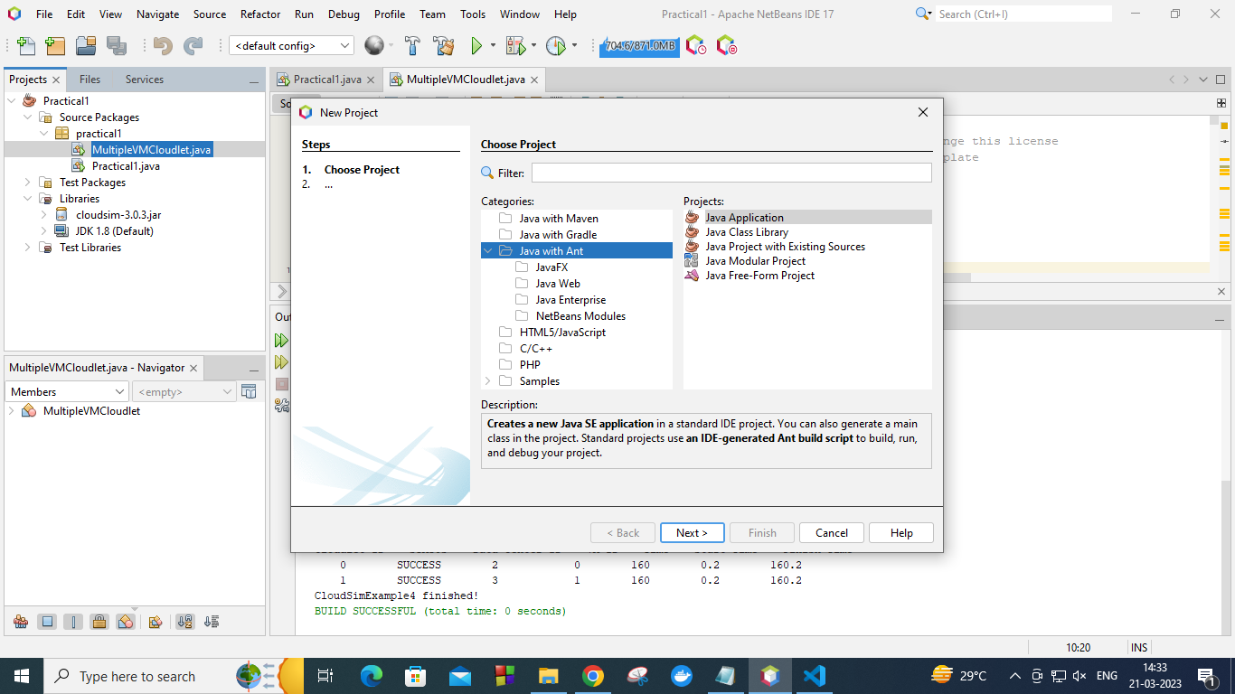

Click next

Set project name as ‘RintronGlade’

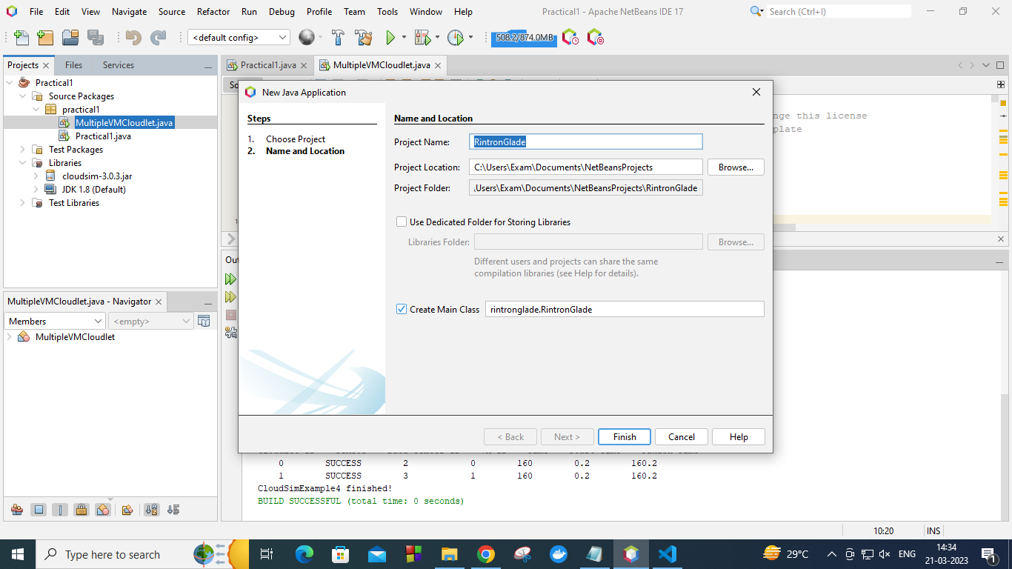

Click finish

Now right click on project and go to configuration and go to customise

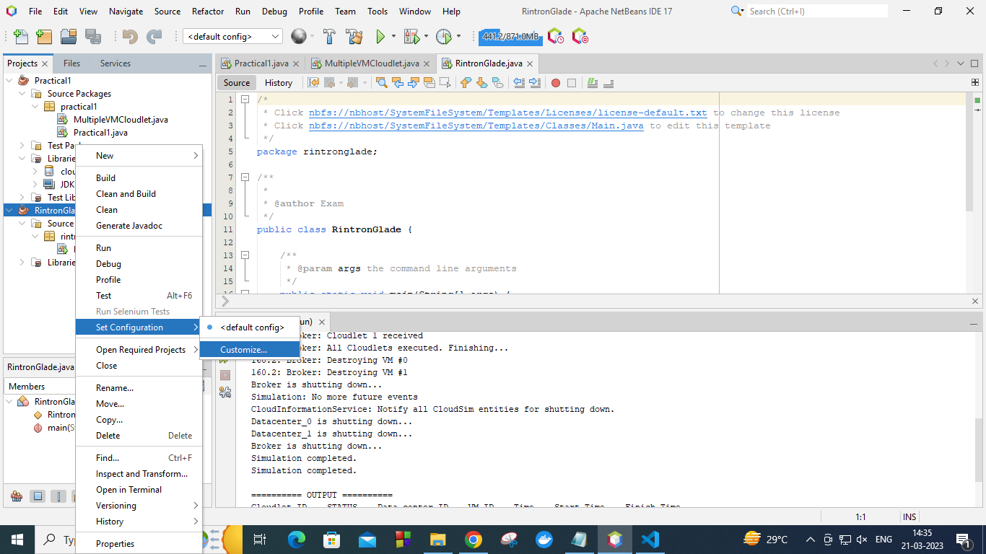

Select libraries

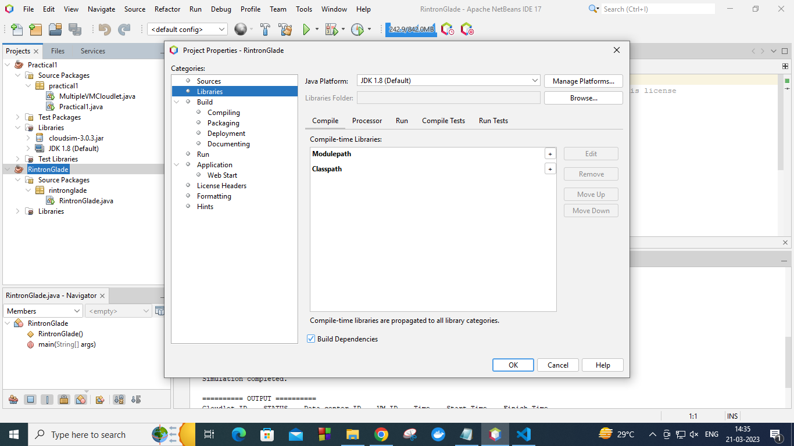

Click on this plus icon to the right side of ClassPath

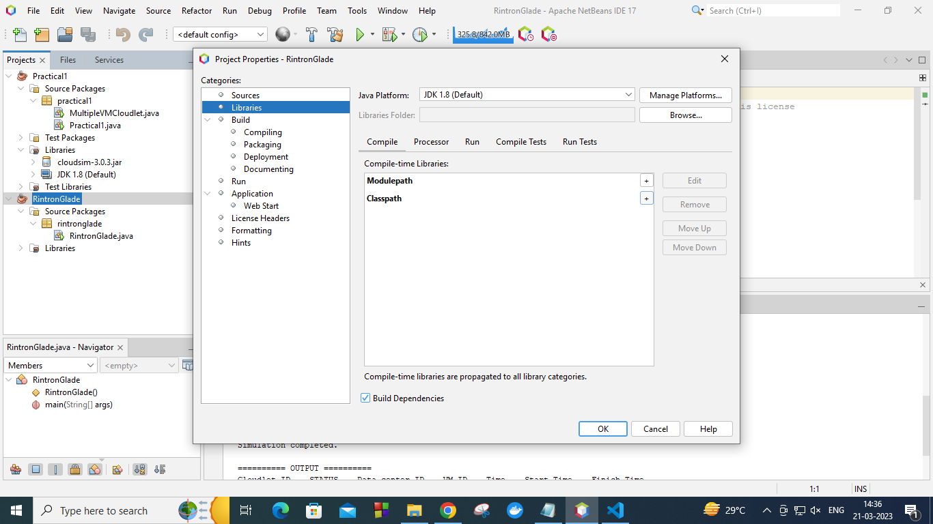

Now create a folder in C drive name as ‘lib’ now paste the first jar file of cloudsim into that lib folder, and now locate the jar folder path in the configuration folder

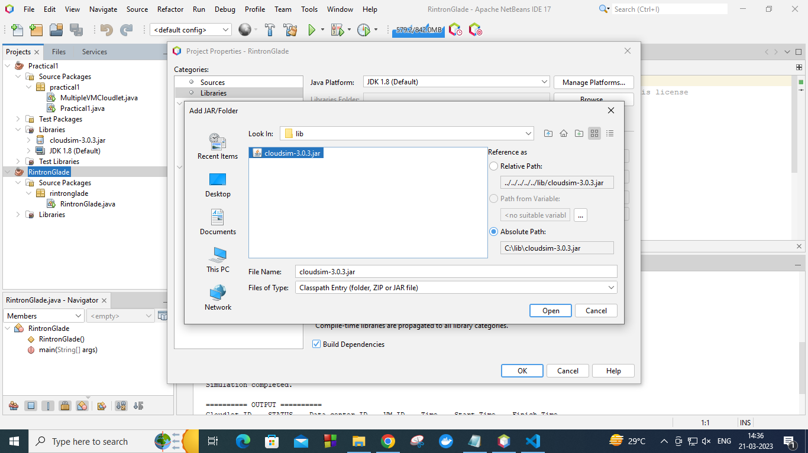

Click open

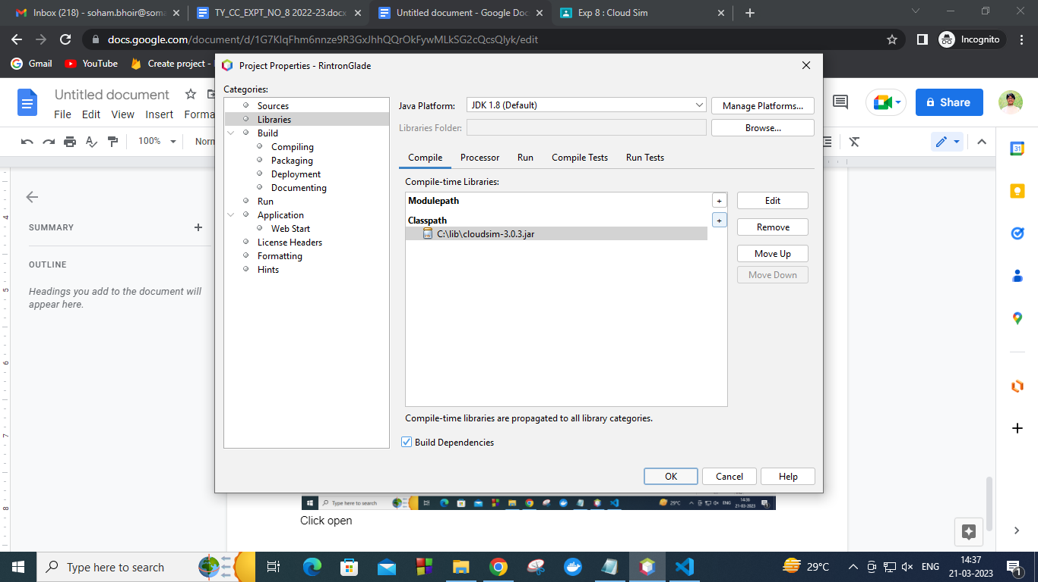

Now click Ok

Now paste this code and run the code

*/\**

*\* Click nbfs://nbhost/SystemFileSystem/Templates/Licenses/license-default.txt to change this license*

*\* Click nbfs://nbhost/SystemFileSystem/Templates/Classes/Main.java to edit this template*

*\*/*

*package rintronglade;*

*/\**

*\* To change this license header, choose License Headers in Project Properties.*

*\* To change this template file, choose Tools | Templates*

*\* and open the template in the editor.*

*\*/*

*/\*\**

*\**

*\* @author nSense*

*\*/*

*import java.text.DecimalFormat;*

*import java.util.ArrayList;*

*import java.util.Calendar;*

*import java.util.LinkedList;*

*import java.util.List;*

*import org.cloudbus.cloudsim.Cloudlet;*

*import org.cloudbus.cloudsim.CloudletSchedulerTimeShared;*

*import org.cloudbus.cloudsim.Datacenter;*

*import org.cloudbus.cloudsim.DatacenterBroker;*

*import org.cloudbus.cloudsim.DatacenterCharacteristics;*

*import org.cloudbus.cloudsim.Host;*

*import org.cloudbus.cloudsim.Log;*

*import org.cloudbus.cloudsim.Pe;*

*import org.cloudbus.cloudsim.Storage;*

*import org.cloudbus.cloudsim.UtilizationModel;*

*import org.cloudbus.cloudsim.UtilizationModelFull;*

*import org.cloudbus.cloudsim.Vm;*

*import org.cloudbus.cloudsim.VmAllocationPolicySimple;*

*import org.cloudbus.cloudsim.VmSchedulerTimeShared;*

*import org.cloudbus.cloudsim.core.CloudSim;*

*import org.cloudbus.cloudsim.provisioners.BwProvisionerSimple;*

*import org.cloudbus.cloudsim.provisioners.PeProvisionerSimple;*

*import org.cloudbus.cloudsim.provisioners.RamProvisionerSimple;*

*public class RintronGlade {*

*/\*\**

*\* The cloudlet list.*

*\*/*

*private static List<Cloudlet> cloudletList;*

*/\*\**

*\* The vmlist.*

*\*/*

*private static List<Vm> vmlist;*

*/\*\**

*\* Creates main() to run this example. MSC Semester-III Paper III (Cloud*

*\* Computing) Mrs. Vaidehi Deshpande,RJC*

*\**

*\* @param args the args*

*\*/*

*@SuppressWarnings("unused")*

*public static void main(String[] args) {*

*Log.printLine("Starting CloudSimExample1...");*

*try {*

*int num_user = 1;*

*Calendar calendar = Calendar.getInstance();*

*boolean trace_flag = false; // mean trace events Initialize the CloudSim library*

*CloudSim.init(num_user, calendar, trace_flag);*

*Datacenter datacenter0 = createDatacenter("Datacenter_0");*

*DatacenterBroker broker = createBroker();*

*int brokerId = broker.getId();*

*vmlist = new ArrayList<Vm>();*

*int vmid = 0;*

*int mips = 1000;*

*long size = 10000; // image size (MB)*

*int ram = 512; // vm memory (MB)*

*long bw = 1000;*

*int pesNumber = 1; // number of cpus*

*String vmm = "Xen"; // VMM name*

*// create VM*

*Vm vm = new Vm(vmid, brokerId, mips, pesNumber, ram, bw, size, vmm, new CloudletSchedulerTimeShared());*

*// add the VM to the vmList*

*vmlist.add(vm);*

*// submit vm list to the broker*

*broker.submitVmList(vmlist);*

*// Fifth step: Create one Cloudlet*

*cloudletList = new ArrayList<Cloudlet>();*

*// Cloudlet properties*

*int id = 0;*

*long length = 400000;*

*long fileSize = 300;*

*long outputSize = 300;*

*UtilizationModel utilizationModel = new UtilizationModelFull();*

*Cloudlet cloudlet = new Cloudlet(id, length, pesNumber, fileSize, outputSize, utilizationModel, utilizationModel, utilizationModel);*

*cloudlet.setUserId(brokerId);*

*cloudlet.setVmId(vmid);*

*// add the cloudlet to the list*

*cloudletList.add(cloudlet);*

*// submit cloudlet list to the broker*

*broker.submitCloudletList(cloudletList);*

*// Sixth step: Starts the simulation*

*CloudSim.startSimulation();*

*CloudSim.stopSimulation();*

*List<Cloudlet> newList = broker.getCloudletReceivedList();*

*printCloudletList(newList);*

*Log.printLine("CloudSimExample1 finished!");*

*} catch (Exception e) {*

*e.printStackTrace();*

*Log.printLine("Unwanted errors happen");*

*}*

*}*

*/\*\**

*\* Creates the datacenter.*

*\**

*\* @param name the name*

*\**

*\* @return the datacenter*

*\*/*

*private static Datacenter createDatacenter(String name) {*

*// Here are the steps needed to create a PowerDatacenter:*

*// 1. We need to create a list to store*

*// our machine*

*List<Host> hostList = new ArrayList<Host>();*

*// 2. A Machine contains one or more PEs or CPUs/Cores.*

*// In this example, it will have only one core.*

*List<Pe> peList = new ArrayList<Pe>();*

*int mips = 1000;*

*// 3. Create PEs and add these into a list.*

*peList.add(new Pe(0, new PeProvisionerSimple(mips))); // need to store Pe id and MIPS Rating*

*// 4. Create Host with its id and list of PEs and add them to the list of machines*

*int hostId = 0;*

*int ram = 2048; // host memory (MB)*

*long storage = 1000000; // host storage*

*int bw = 10000;*

*hostList.add(*

*new Host(*

*hostId,*

*new RamProvisionerSimple(ram),*

*new BwProvisionerSimple(bw),*

*storage,*

*peList,*

*new VmSchedulerTimeShared(peList)*

*)*

*); // This is our machine*

*// 5. Create a DatacenterCharacteristics object that stores the*

*// properties of a data center: architecture, OS, list of*

*// Machines, allocation policy: time- or space-shared, time zone*

*// and its price (G$/Pe time unit).*

*String arch = "x86"; // system architecture*

*String os = "Linux"; // operating system*

*String vmm = "Xen";*

*double time_zone = 10.0; // time zone this resource located*

*double cost = 3.0; // the cost of using processing in this resource*

*double costPerMem = 0.05; // the cost of using memory in this resource*

*double costPerStorage = 0.001; // the cost of using storage in this resource*

*double costPerBw = 0.0; // the cost of using bw in this resource*

*// we are not adding SAN devices by now*

*LinkedList<Storage> storageList = new LinkedList<Storage>();*

*DatacenterCharacteristics characteristics*

*= new DatacenterCharacteristics(arch, os, vmm, hostList, time_zone, cost, costPerMem,*

*costPerStorage, costPerBw);*

*// 6. Finally, we need to create a PowerDatacenter object.*

*Datacenter datacenter = null;*

*try {*

*datacenter = new Datacenter(name, characteristics, new VmAllocationPolicySimple(hostList), storageList, 0);*

*} catch (Exception e) {*

*e.printStackTrace();*

*}*

*return datacenter;*

*}*

*// We strongly encourage users to develop their own broker policies, to*

*// submit vms and cloudlets according*

*// to the specific rules of the simulated scenario*

*/\*\**

*\* Creates the broker.*

*\**

*\* @return the datacenter broker*

*\*/*

*private static DatacenterBroker createBroker() {*

*DatacenterBroker broker = null;*

*try {*

*broker = new DatacenterBroker("Broker");*

*} catch (Exception e) {*

*e.printStackTrace();*

*return null;*

*}*

*return broker;*

*}*

*/\*\**

*\* Prints the Cloudlet objects.*

*\**

*\* @param list list of Cloudlets*

*\*/*

*private static void printCloudletList(List<Cloudlet> list) {*

*int size = list.size();*

*Cloudlet cloudlet;*

*String indent = " ";*

*Log.printLine();*

*Log.printLine("========== OUTPUT ==========");*

*Log.printLine("Cloudlet ID" + indent + "STATUS" + indent*

*+ "Data center ID" + indent + "VM ID" + indent + "Time" + indent*

*+ "Start Time" + indent + "Finish Time");*

*DecimalFormat dft = new DecimalFormat("###.##");*

*for (int i = 0; i < size; i++) {*

*cloudlet = list.get(i);*

*Log.print(indent + cloudlet.getCloudletId() + indent + indent);*

*if (cloudlet.getCloudletStatus() == Cloudlet.SUCCESS) {*

*Log.print("SUCCESS");*

*Log.printLine(indent + indent + cloudlet.getResourceId()*

*+ indent + indent + indent + cloudlet.getVmId()*

*+ indent + indent*

*+ dft.format(cloudlet.getActualCPUTime()) + indent*

*+ indent + dft.format(cloudlet.getExecStartTime())*

*+ indent + indent*

*+ dft.format(cloudlet.getFinishTime())*

*);*

*}*

*}*

*}*

*}*

Click run

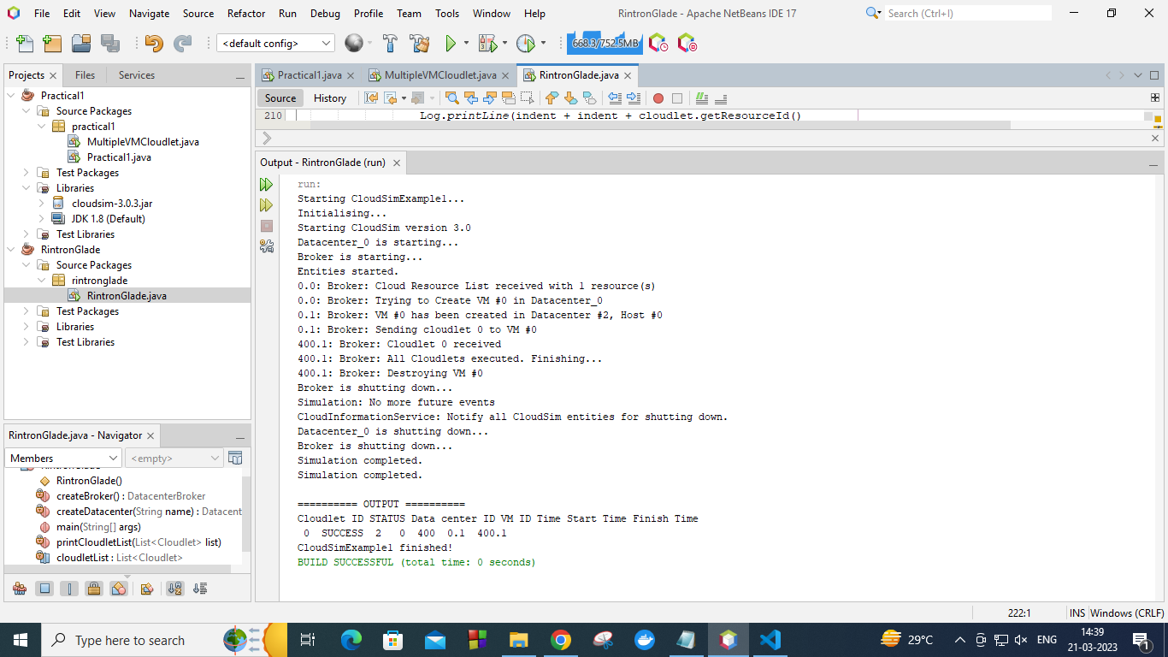

Now create new class and run the following code

*For multiple VM cloudlet*

*/\**

*\* Click nbfs://nbhost/SystemFileSystem/Templates/Licenses/license-default.txt to change this license*

*\* Click nbfs://nbhost/SystemFileSystem/Templates/Classes/Class.java to edit this template*

*\*/*

*package rintronglade;*

*import java.text.DecimalFormat;*

*import java.util.ArrayList;*

*import java.util.Calendar;*

*import java.util.LinkedList;*

*import java.util.List;*

*import org.cloudbus.cloudsim.Cloudlet;*

*import org.cloudbus.cloudsim.CloudletSchedulerTimeShared;*

*import org.cloudbus.cloudsim.Datacenter;*

*import org.cloudbus.cloudsim.DatacenterBroker;*

*import org.cloudbus.cloudsim.DatacenterCharacteristics;*

*import org.cloudbus.cloudsim.Host;*

*import org.cloudbus.cloudsim.Log;*

*import org.cloudbus.cloudsim.Pe;*

*import org.cloudbus.cloudsim.Storage;*

*import org.cloudbus.cloudsim.UtilizationModel;*

*import org.cloudbus.cloudsim.UtilizationModelFull;*

*import org.cloudbus.cloudsim.Vm;*

*import org.cloudbus.cloudsim.VmAllocationPolicySimple;*

*import org.cloudbus.cloudsim.VmSchedulerSpaceShared;*

*import org.cloudbus.cloudsim.core.CloudSim;*

*import org.cloudbus.cloudsim.provisioners.BwProvisionerSimple;*

*import org.cloudbus.cloudsim.provisioners.PeProvisionerSimple;*

*import org.cloudbus.cloudsim.provisioners.RamProvisionerSimple;*

*/\*\**

*\* A simple example showing how to create*

*\* two datacenters with one host each and*

*\* run two cloudlets on them.*

*\*/*

*public class MultipleVMCloudlet {*

*/** The cloudlet list. */*

*private static List<Cloudlet> cloudletList;*

*/** The vmlist. */*

*private static List<Vm> vmlist;*

*/\*\**

*\* Creates main() to run this example*

*\*/*

*public static void main(String[] args) {*

*Log.printLine("Starting CloudSimExample4...");*

*try {*

*// First step: Initialize the CloudSim package. It should be called*

*// before creating any entities.*

*int num_user = 1; // number of cloud users*

*Calendar calendar = Calendar.getInstance();*

*boolean trace_flag = false; // mean trace events*

*// Initialize the GridSim library*

*CloudSim.init(num_user, calendar, trace_flag);*

*// Second step: Create Datacenters*

*//Datacenters are the resource providers in CloudSim. We need at list one of them to run a CloudSim simulation*

*@SuppressWarnings("unused")*

*Datacenter datacenter0 = createDatacenter("Datacenter_0");*

*@SuppressWarnings("unused")*

*Datacenter datacenter1 = createDatacenter("Datacenter_1");*

*//Third step: Create Broker*

*DatacenterBroker broker = createBroker();*

*int brokerId = broker.getId();*

*//Fourth step: Create one virtual machine*

*vmlist = new ArrayList<Vm>();*

*//VM description*

*int vmid = 0;*

*int mips = 250;*

*long size = 10000; //image size (MB)*

*int ram = 512; //vm memory (MB)*

*long bw = 1000;*

*int pesNumber = 1; //number of cpus*

*String vmm = "Xen"; //VMM name*

*//create two VMs*

*Vm vm1 = new Vm(vmid, brokerId, mips, pesNumber, ram, bw, size, vmm, new CloudletSchedulerTimeShared());*

*vmid++;*

*Vm vm2 = new Vm(vmid, brokerId, mips, pesNumber, ram, bw, size, vmm, new CloudletSchedulerTimeShared());*

*//add the VMs to the vmList*

*vmlist.add(vm1);*

*vmlist.add(vm2);*

*//submit vm list to the broker*

*broker.submitVmList(vmlist);*

*//Fifth step: Create two Cloudlets*

*cloudletList = new ArrayList<Cloudlet>();*

*//Cloudlet properties*

*int id = 0;*

*long length = 40000;*

*long fileSize = 300;*

*long outputSize = 300;*

*UtilizationModel utilizationModel = new UtilizationModelFull();*

*Cloudlet cloudlet1 = new Cloudlet(id, length, pesNumber, fileSize, outputSize, utilizationModel, utilizationModel, utilizationModel);*

*cloudlet1.setUserId(brokerId);*

*id++;*

*Cloudlet cloudlet2 = new Cloudlet(id, length, pesNumber, fileSize, outputSize, utilizationModel, utilizationModel, utilizationModel);*

*cloudlet2.setUserId(brokerId);*

*//add the cloudlets to the list*

*cloudletList.add(cloudlet1);*

*cloudletList.add(cloudlet2);*

*//submit cloudlet list to the broker*

*broker.submitCloudletList(cloudletList);*

*//bind the cloudlets to the vms. This way, the broker*

*// will submit the bound cloudlets only to the specific VM*

*broker.bindCloudletToVm(cloudlet1.getCloudletId(),vm1.getId());*

*broker.bindCloudletToVm(cloudlet2.getCloudletId(),vm2.getId());*

*// Sixth step: Starts the simulation*

*CloudSim.startSimulation();*

*// Final step: Print results when simulation is over*

*List<Cloudlet> newList = broker.getCloudletReceivedList();*

*CloudSim.stopSimulation();*

*printCloudletList(newList);*

*Log.printLine("CloudSimExample4 finished!");*

*}*

*catch (Exception e) {*

*e.printStackTrace();*

*Log.printLine("The simulation has been terminated due to an unexpected error");*

*}*

*}*

*private static Datacenter createDatacenter(String name){*

*// Here are the steps needed to create a PowerDatacenter:*

*// 1. We need to create a list to store*

*// our machine*

*List<Host> hostList = new ArrayList<Host>();*

*// 2. A Machine contains one or more PEs or CPUs/Cores.*

*// In this example, it will have only one core.*

*List<Pe> peList = new ArrayList<Pe>();*

*int mips = 1000;*

*// 3. Create PEs and add these into a list.*

*peList.add(new Pe(0, new PeProvisionerSimple(mips))); // need to store Pe id and MIPS Rating*

*//4. Create Host with its id and list of PEs and add them to the list of machines*

*int hostId=0;*

*int ram = 2048; //host memory (MB)*

*long storage = 1000000; //host storage*

*int bw = 10000;*

*//in this example, the VMAllocatonPolicy in use is SpaceShared. It means that only one VM*

*//is allowed to run on each Pe. As each Host has only one Pe, only one VM can run on each Host.*

*hostList.add(*

*new Host(*

*hostId,*

*new RamProvisionerSimple(ram),*

*new BwProvisionerSimple(bw),*

*storage,*

*peList,*

*new VmSchedulerSpaceShared(peList)*

*)*

*); // This is our first machine*

*// 5. Create a DatacenterCharacteristics object that stores the*

*// properties of a data center: architecture, OS, list of*

*// Machines, allocation policy: time- or space-shared, time zone*

*// and its price (G$/Pe time unit).*

*String arch = "x86"; // system architecture*

*String os = "Linux"; // operating system*

*String vmm = "Xen";*

*double time_zone = 10.0; // time zone this resource located*

*double cost = 3.0; // the cost of using processing in this resource*

*double costPerMem = 0.05; // the cost of using memory in this resource*

*double costPerStorage = 0.001; // the cost of using storage in this resource*

*double costPerBw = 0.0; // the cost of using bw in this resource*

*LinkedList<Storage> storageList = new LinkedList<Storage>(); //we are not adding SAN devices by now*

*DatacenterCharacteristics characteristics = new DatacenterCharacteristics(*

*arch, os, vmm, hostList, time_zone, cost, costPerMem, costPerStorage, costPerBw);*

*// 6. Finally, we need to create a PowerDatacenter object.*

*Datacenter datacenter = null;*

*try {*

*datacenter = new Datacenter(name, characteristics, new VmAllocationPolicySimple(hostList), storageList, 0);*

*} catch (Exception e) {*

*e.printStackTrace();*

*}*

*return datacenter;*

*}*

*//We strongly encourage users to develop their own broker policies, to submit vms and cloudlets according*

*//to the specific rules of the simulated scenario*

*private static DatacenterBroker createBroker(){*

*DatacenterBroker broker = null;*

*try {*

*broker = new DatacenterBroker("Broker");*

*} catch (Exception e) {*

*e.printStackTrace();*

*return null;*

*}*

*return broker;*

*}*

*/\*\**

*\* Prints the Cloudlet objects*

*\* @param list list of Cloudlets*

*\*/*

*private static void printCloudletList(List<Cloudlet> list) {*

*int size = list.size();*

*Cloudlet cloudlet;*

*String indent = " ";*

*Log.printLine();*

*Log.printLine("========== OUTPUT ==========");*

*Log.printLine("Cloudlet ID" + indent + "STATUS" + indent +*

*"Data center ID" + indent + "VM ID" + indent + "Time" + indent + "Start Time" + indent + "Finish Time");*

*DecimalFormat dft = new DecimalFormat("###.##");*

*for (int i = 0; i < size; i++) {*

*cloudlet = list.get(i);*

*Log.print(indent + cloudlet.getCloudletId() + indent + indent);*

*if (cloudlet.getCloudletStatus() == Cloudlet.SUCCESS){*

*Log.print("SUCCESS");*

*Log.printLine( indent + indent + cloudlet.getResourceId() + indent + indent + indent + cloudlet.getVmId() +*

*indent + indent + dft.format(cloudlet.getActualCPUTime()) + indent + indent + dft.format(cloudlet.getExecStartTime())+*

*indent + indent + dft.format(cloudlet.getFinishTime()));*

*}*

*}*

*}*

*}*

Output

